

HACKATHON-2
Applied Machine Learning for Text Analytics

Team members:
Rahul (2420090043)
Sai Sujith (2420030280)
Nikhileash (2420030596)
Sumanth Reddy (2420030782)

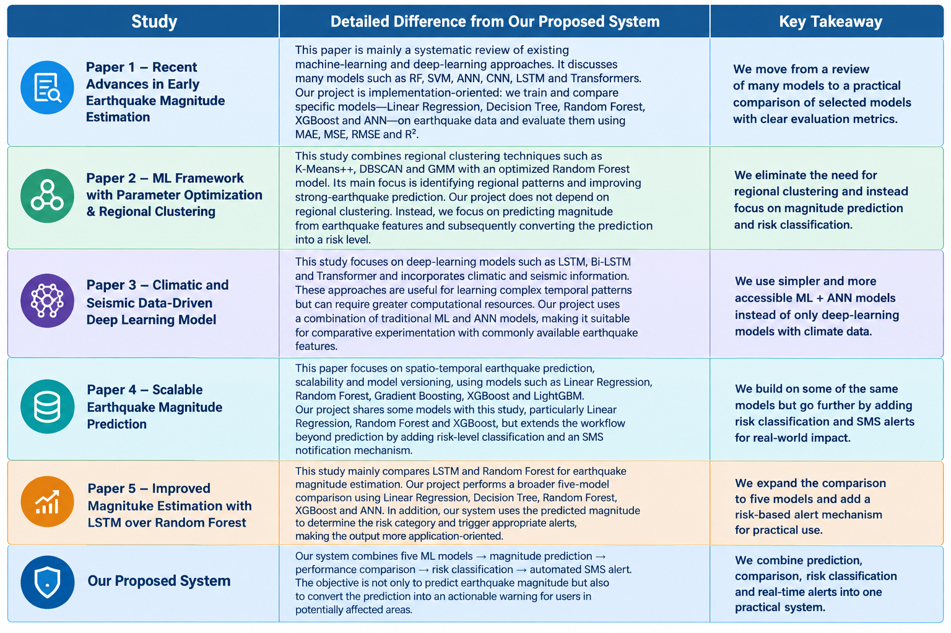

Key Difference in Simple Terms
Existing research:
Earthquake Data → ML/DL Model → Predicted Magnitude
Our proposed system:
Earthquake Data → 5 ML Models → Predicted Magnitude → Risk Level → Affected Area → SMS Alert

Main Research Gap
The reviewed papers address different parts of the problem—deep learning, clustering, climatic data, scalability, or model comparison. Our proposed system combines these prediction capabilities with a practical disaster-response layer, where the predicted magnitude is converted into a risk level and used to generate an automated SMS warning.
This makes the proposed system suitable for a hackathon, because it demonstrates not only the ML prediction but also a clear real-world action based on the prediction.

